**LAB 1**

**NAME:** Amina Noor **REG NO:** 2023-BSE-007  
**CLASS:** BSE-5A

**SUBJECT:** CC

**TASK:**

1. **Install VMware Workstation Pro.**

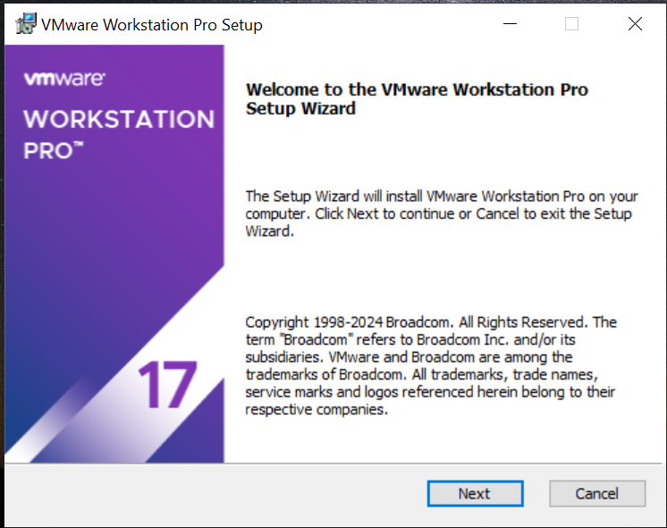

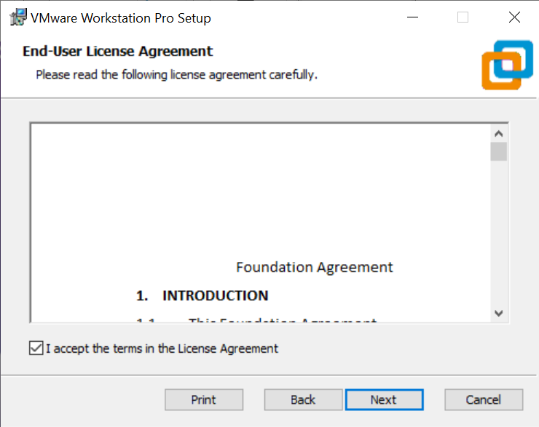

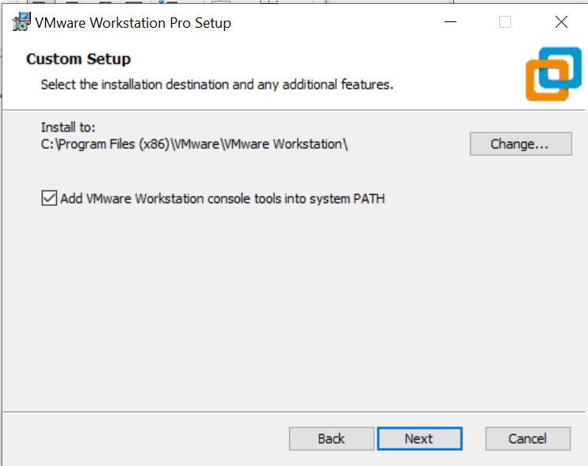

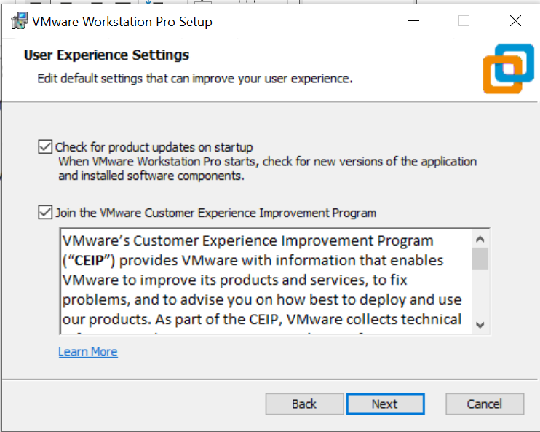

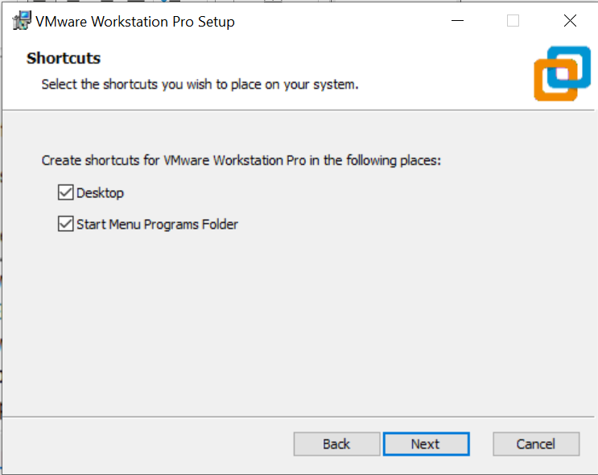

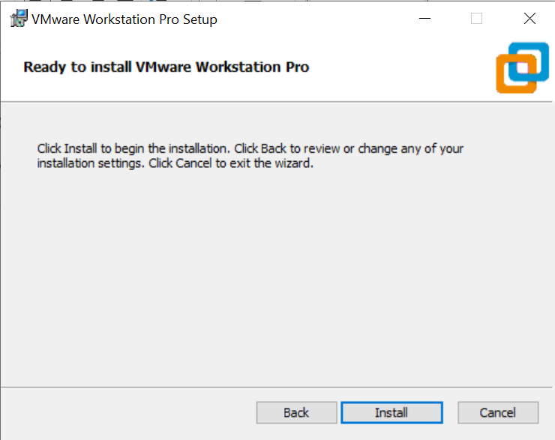

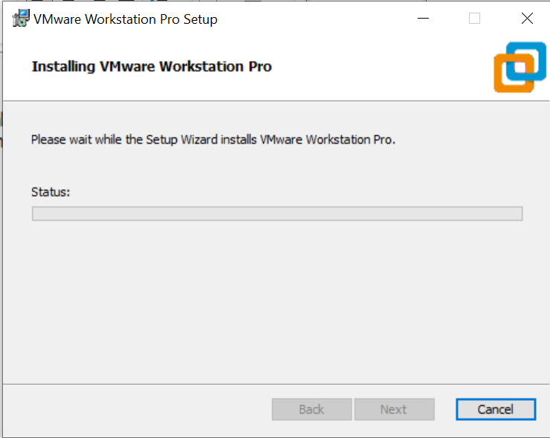

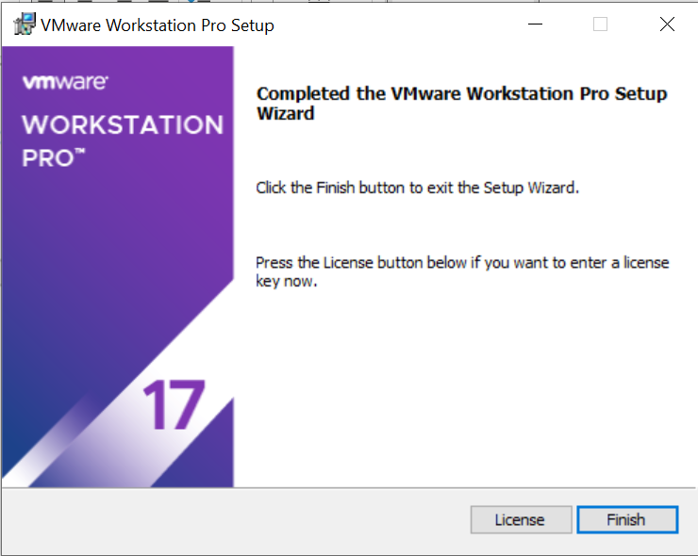

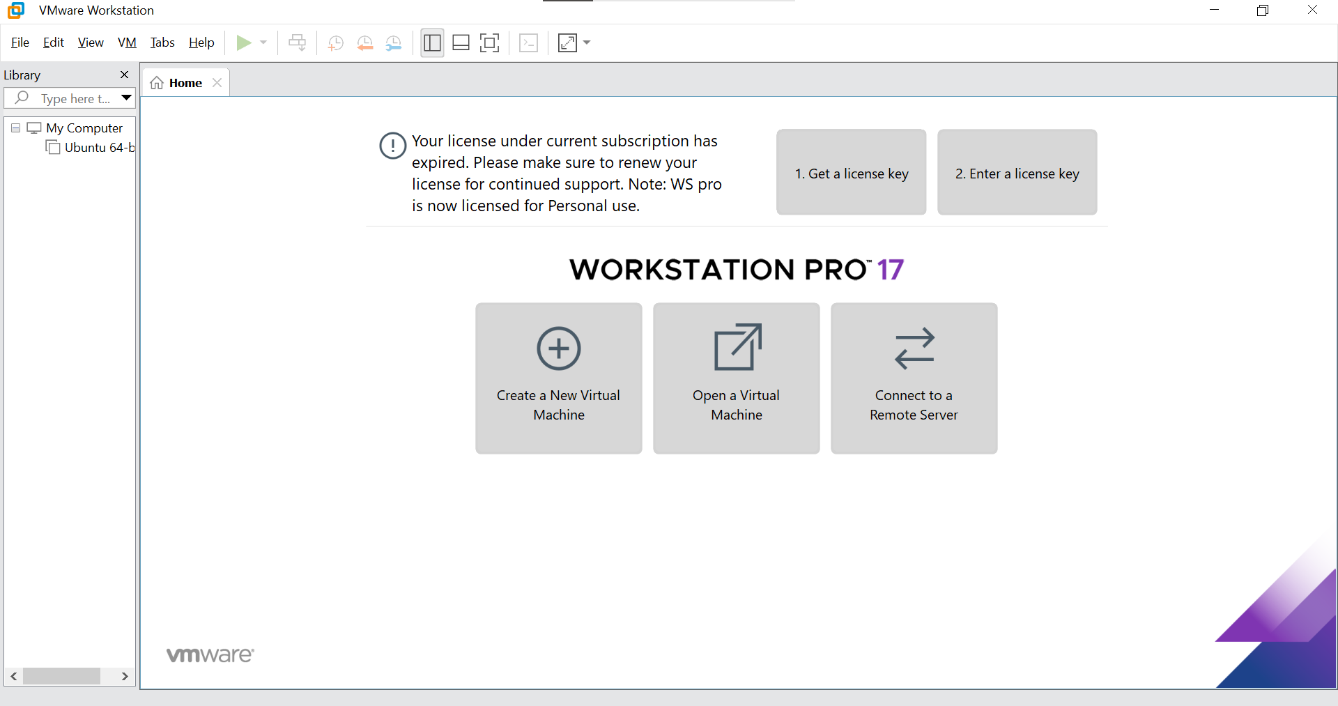

1. **Download Ubuntu Server ISO**

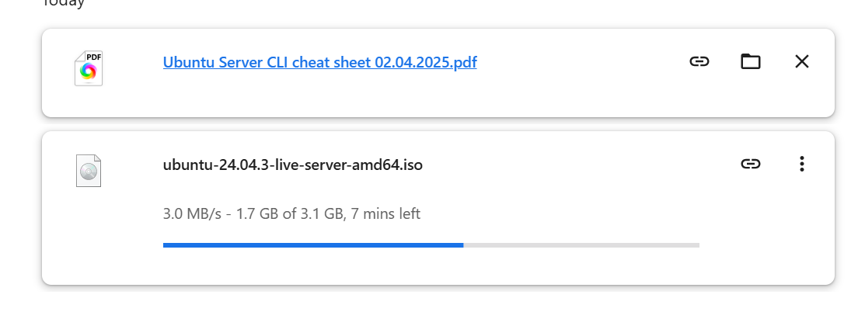

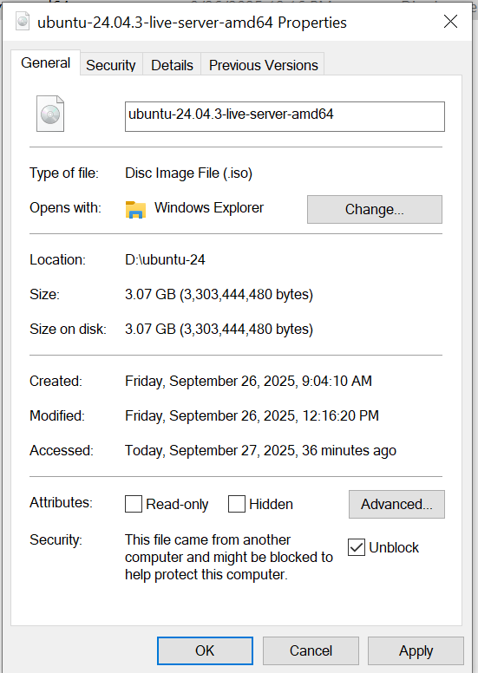

1. **Create a new virtual machine in VMware**

* Open VMware Workstation Pro.
* Click **Create a New Virtual Machine**.
* Select **Typical (recommended)**.
* When asked for installation media, choose **Installer disc image file (ISO)** and browse to the Ubuntu Server ISO you downloaded.
* Continue through the wizard, selecting the defaults unless otherwise instructed.

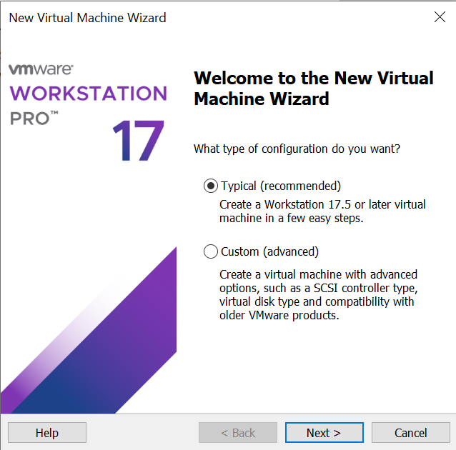

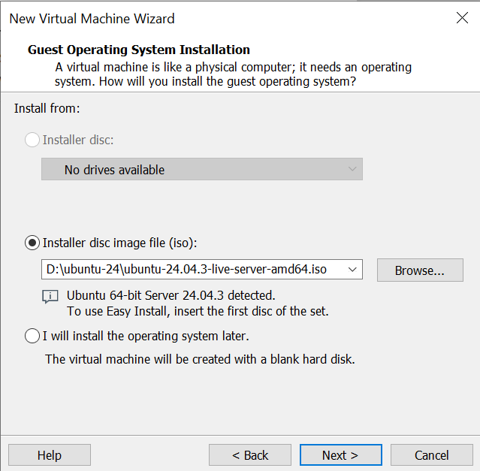

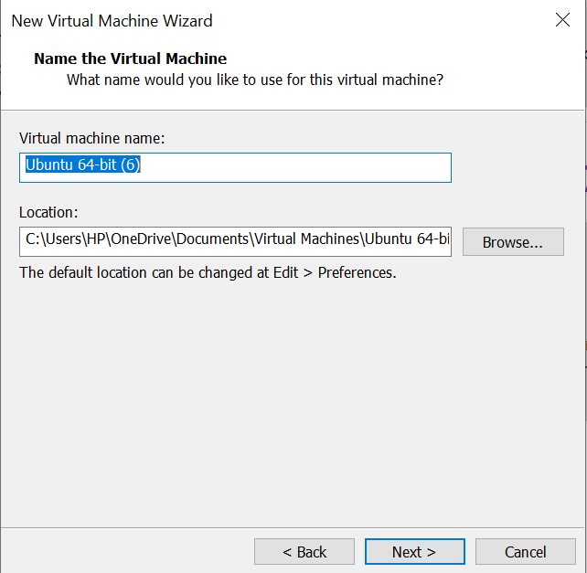

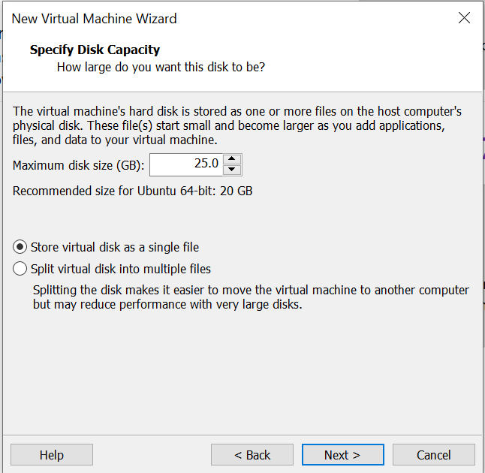

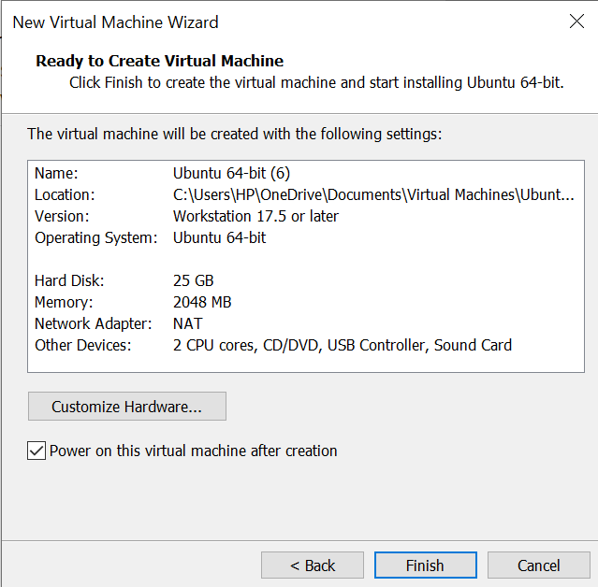

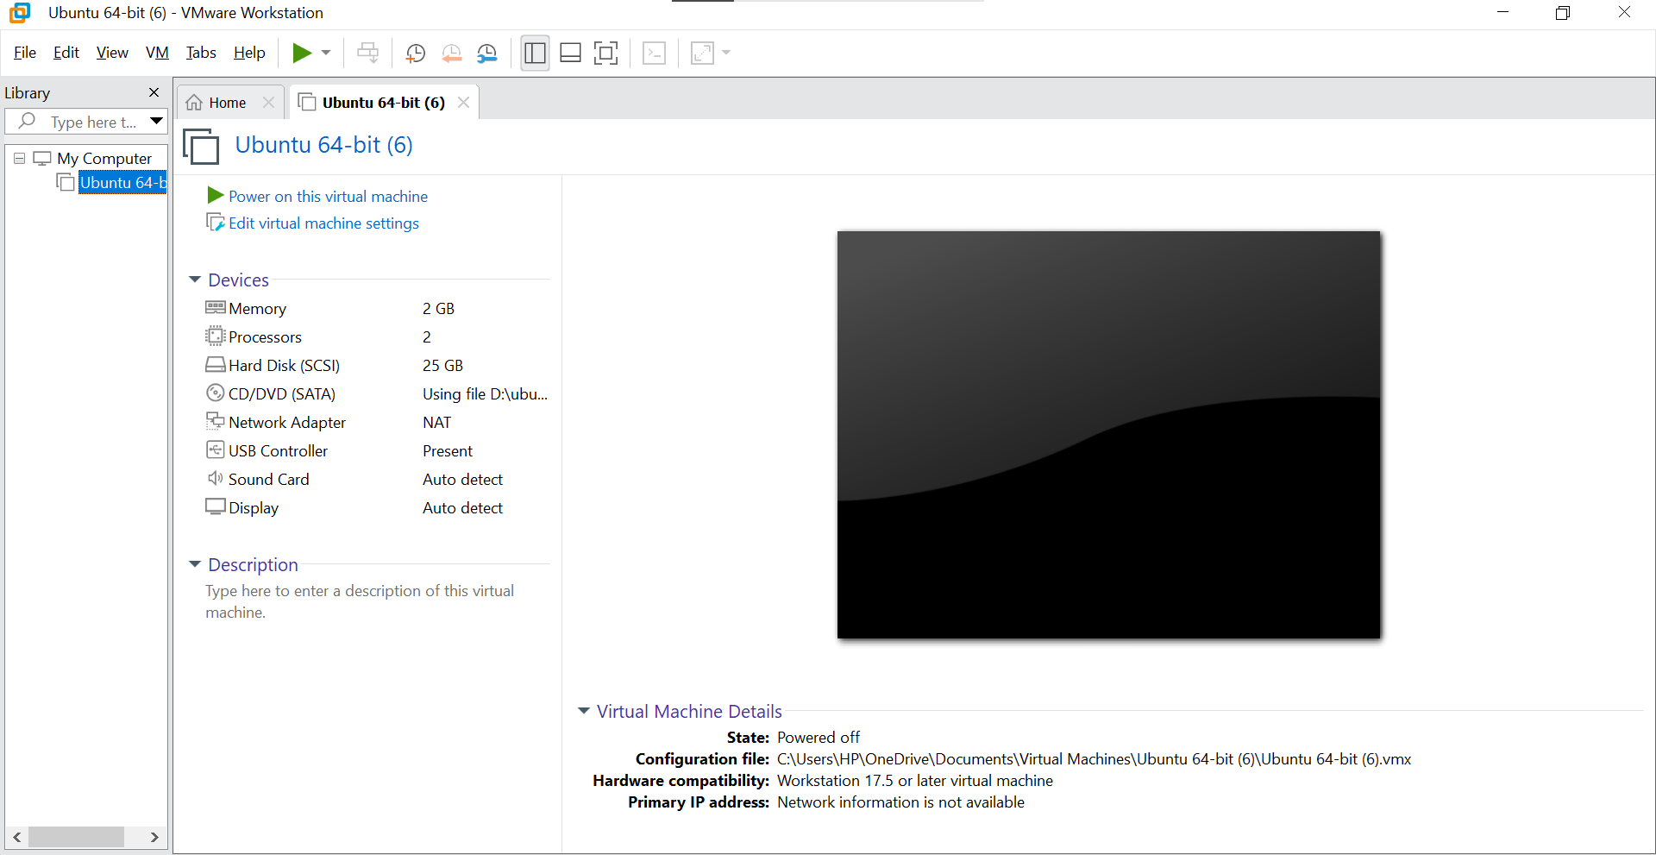

1. **Start the virtual machine**

* Once the VM is created, click Power on this virtual machine.
* The Ubuntu Server installer will boot using the ISO file.

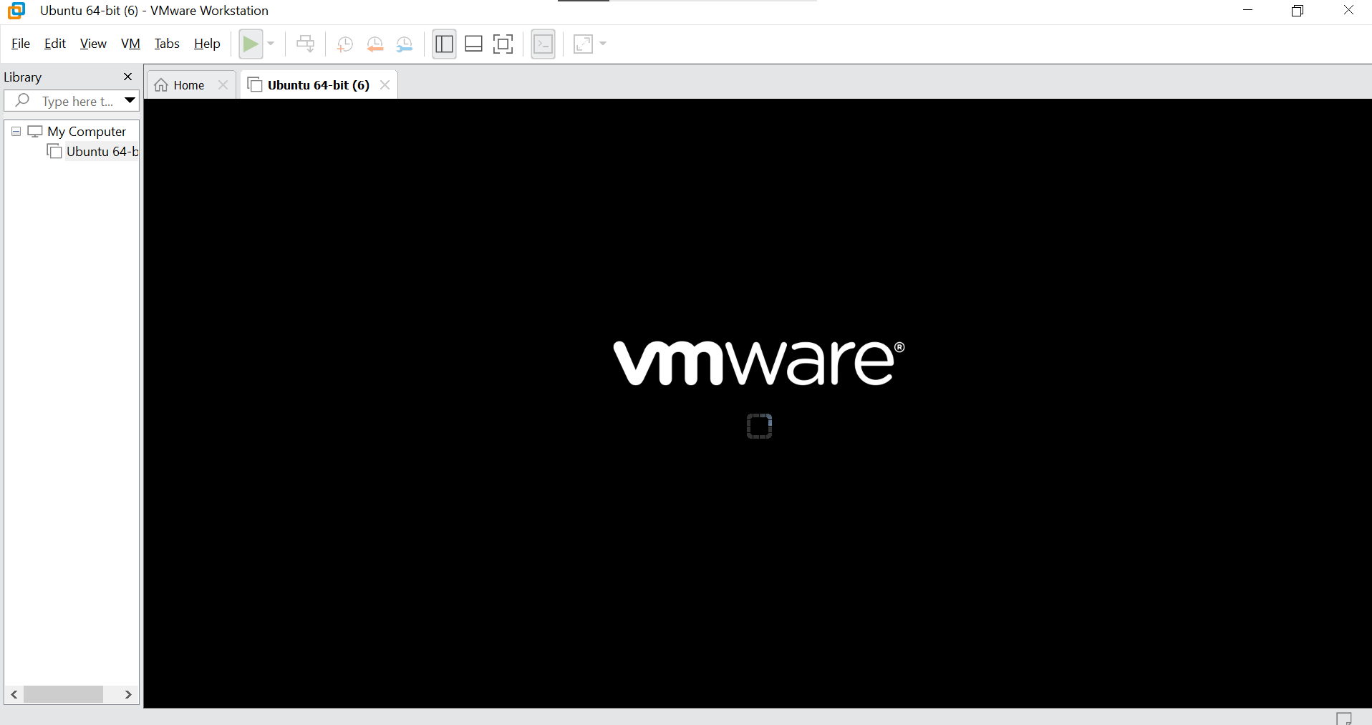

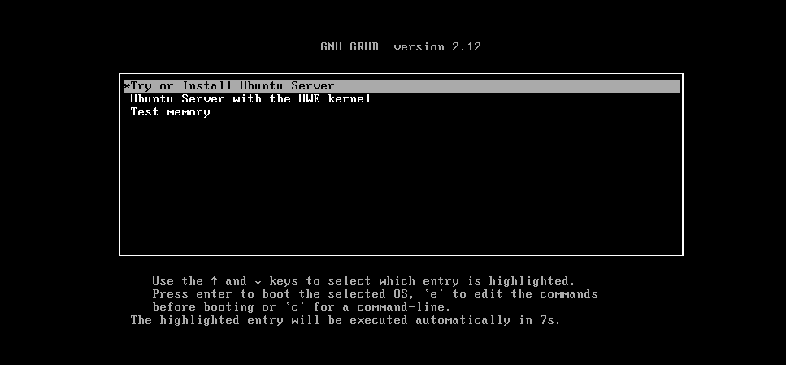

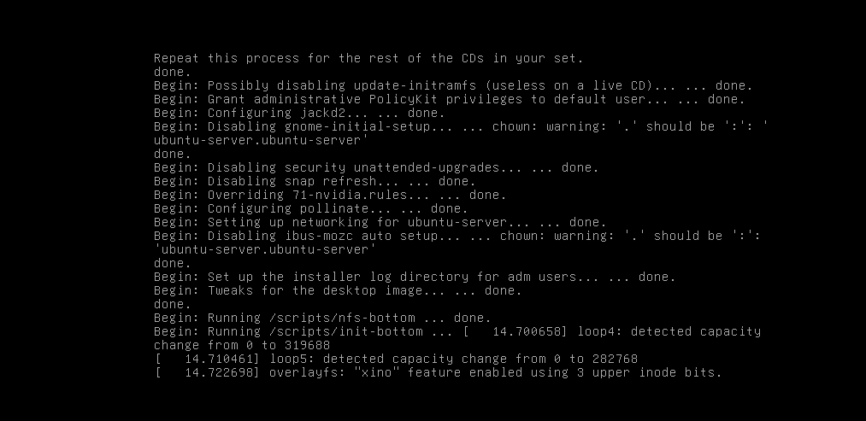

Scroll down using the arrow keys. When done, highlight **Done** at the bottom of the window and press Enter.

Choose your prefer language:

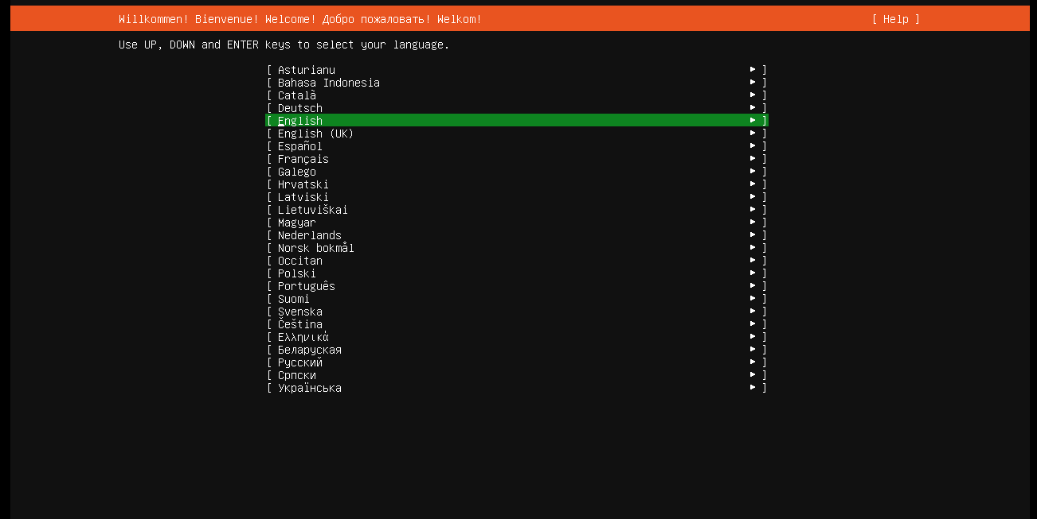

Choose the correct keyboard layout:

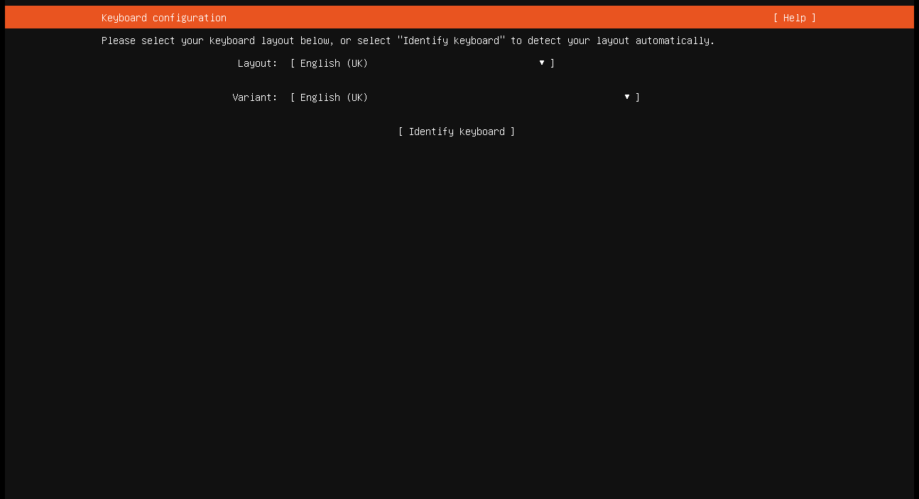

Choose your install:

* When choosing, scroll down using the arrow keys and select with the spacebar. When an (x) appears inside the [ ] brackets, it means that option is selected.

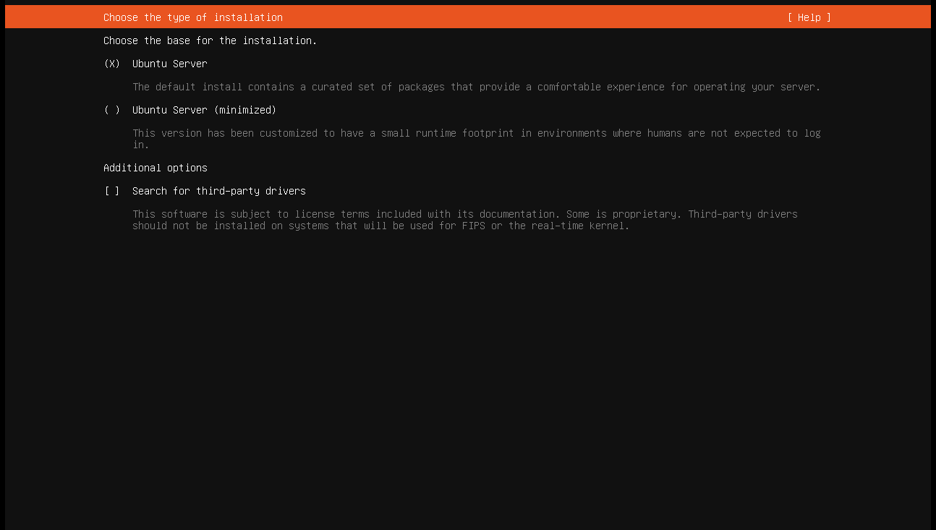

Networking:

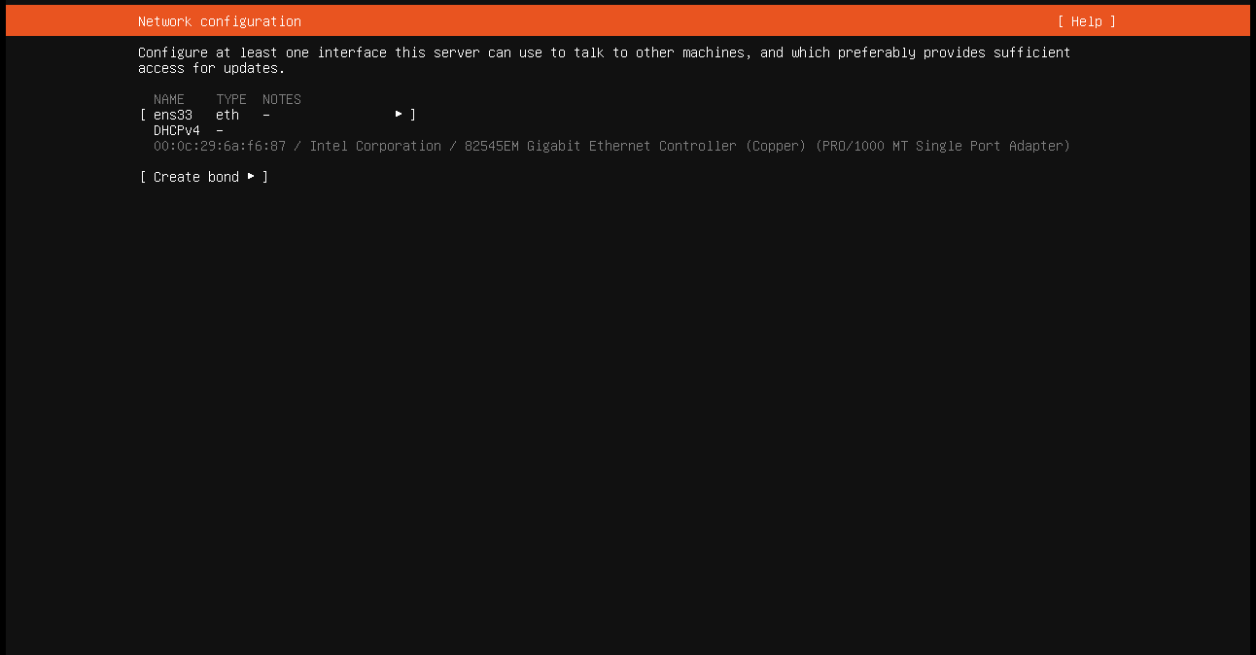

Configure proxy:

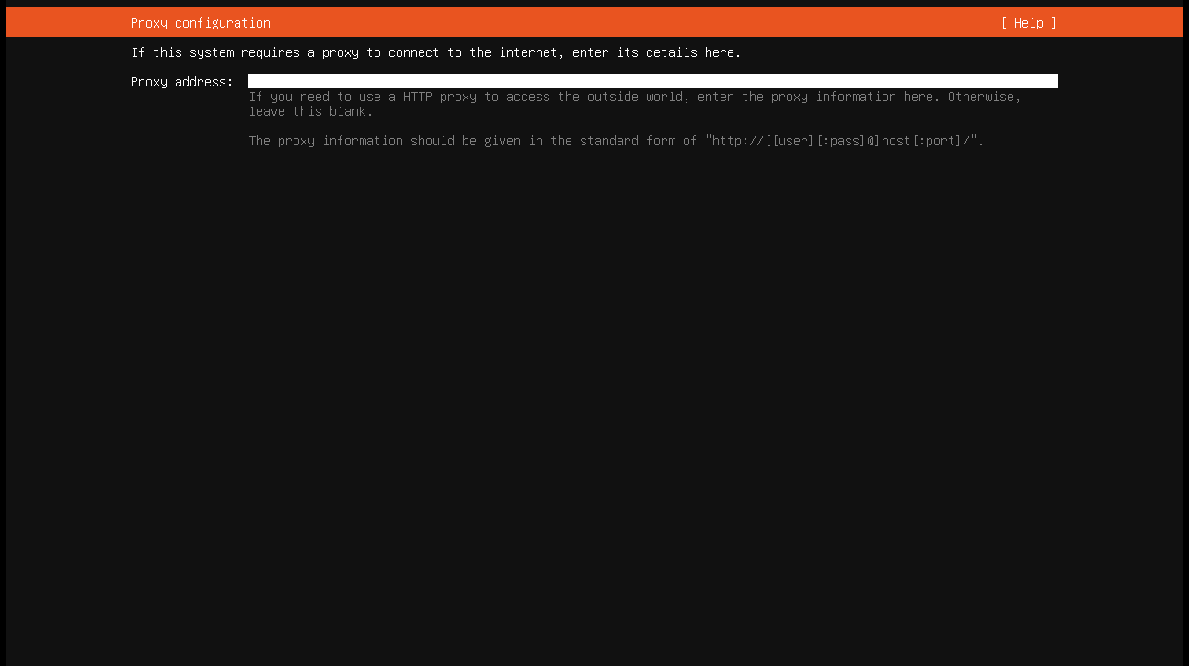

Configure ubuntu archive mirror:

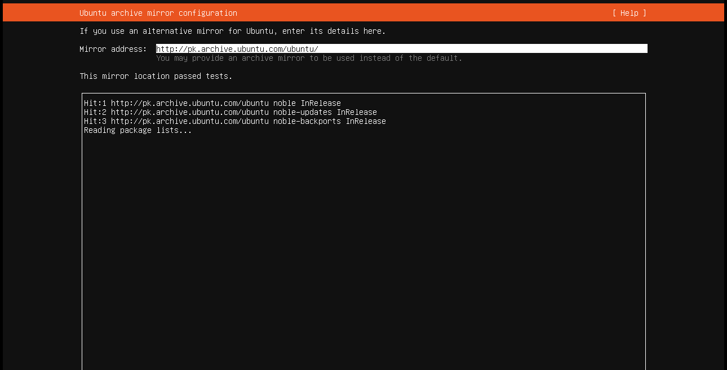

Configure storage guide:

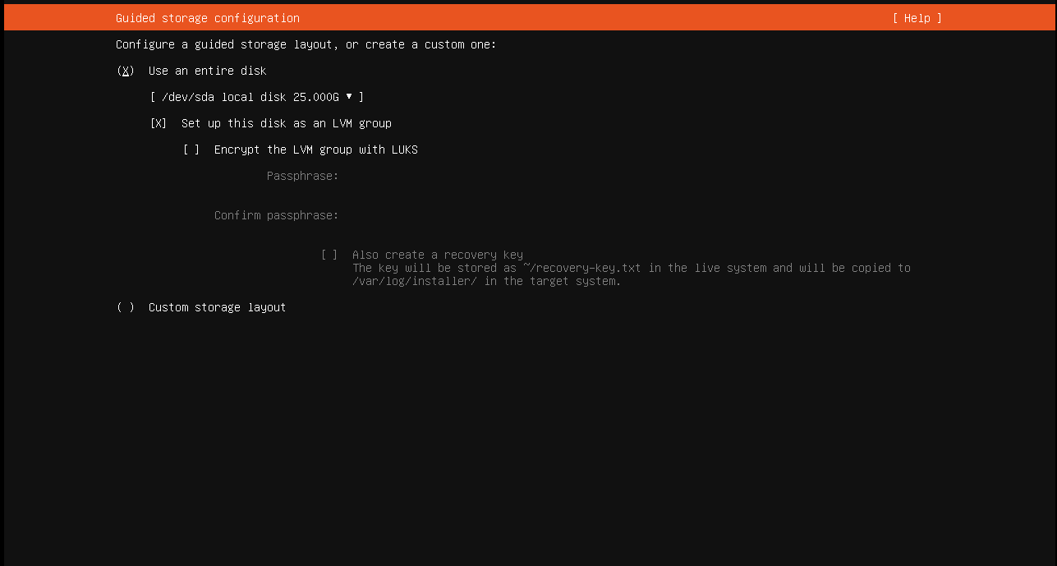

Storage Configuration:

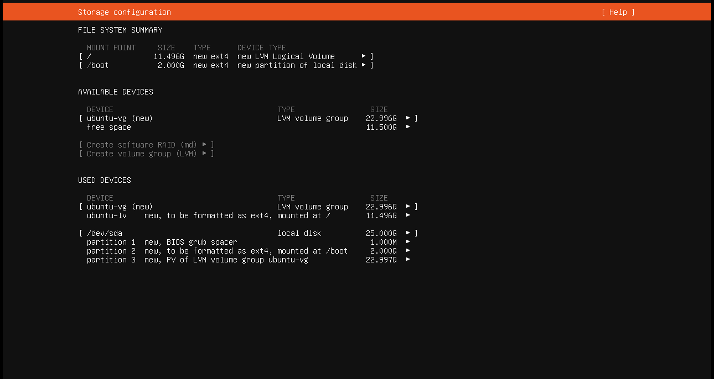

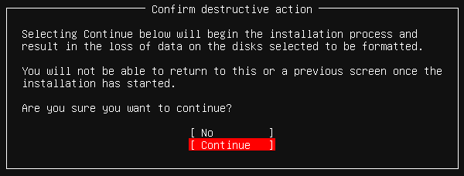

Set up a profile:

Error

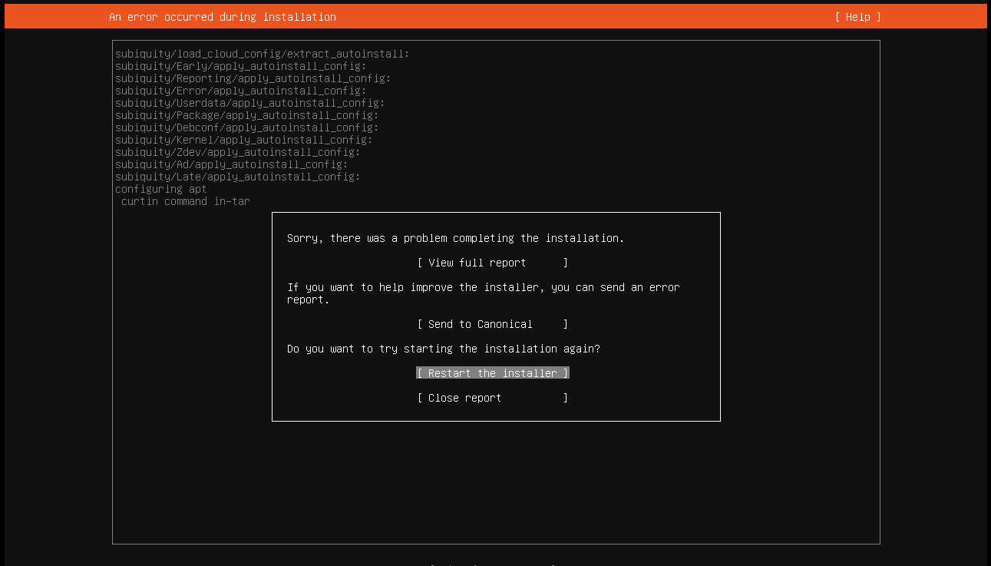

This usually means the installer (subiquity with curtin) had trouble during the **APT package configuration step**. Common causes are:

1. You did not check the ‘**Unblock**’ security option in the properties of the Ubuntu Server file.
2. **No internet connection** (APT cannot fetch required packages).
3. **Bad mirror or repo unreachable** (network timeout or blocked domain).
4. **Corrupted ISO** (installer cannot unpack packages).
5. **Insufficient disk space or partitioning issue**.

**Virtual machine misconfiguration** (if using VMware, VirtualBox, Hyper-V, etc. – sometimes storage controllers cause problems).

Check these problems one by one, and after solving each problem, start again from Step 4 (Start the virtual machine).

Set up a profile:

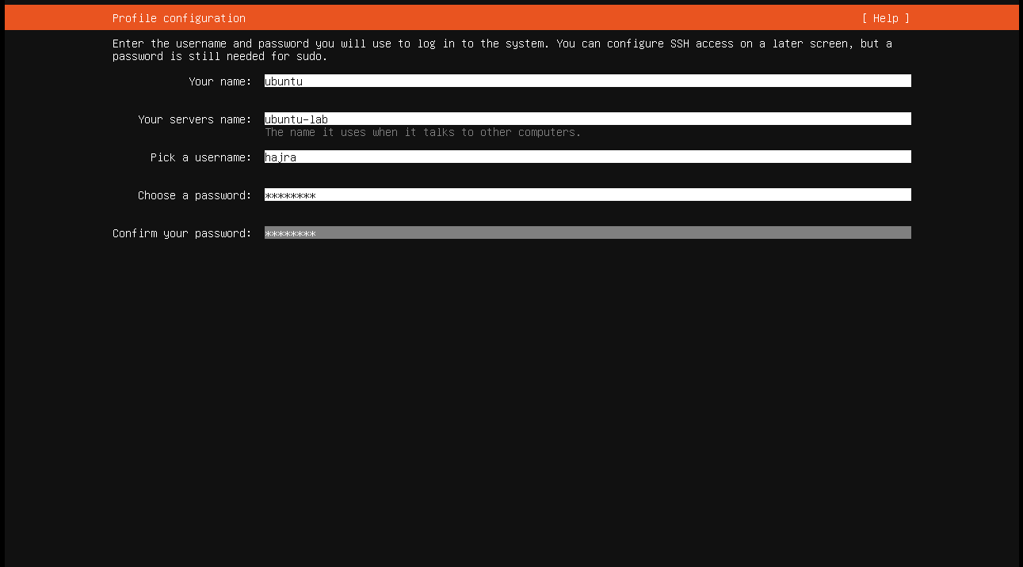

Upgrade to ubuntu Pro:

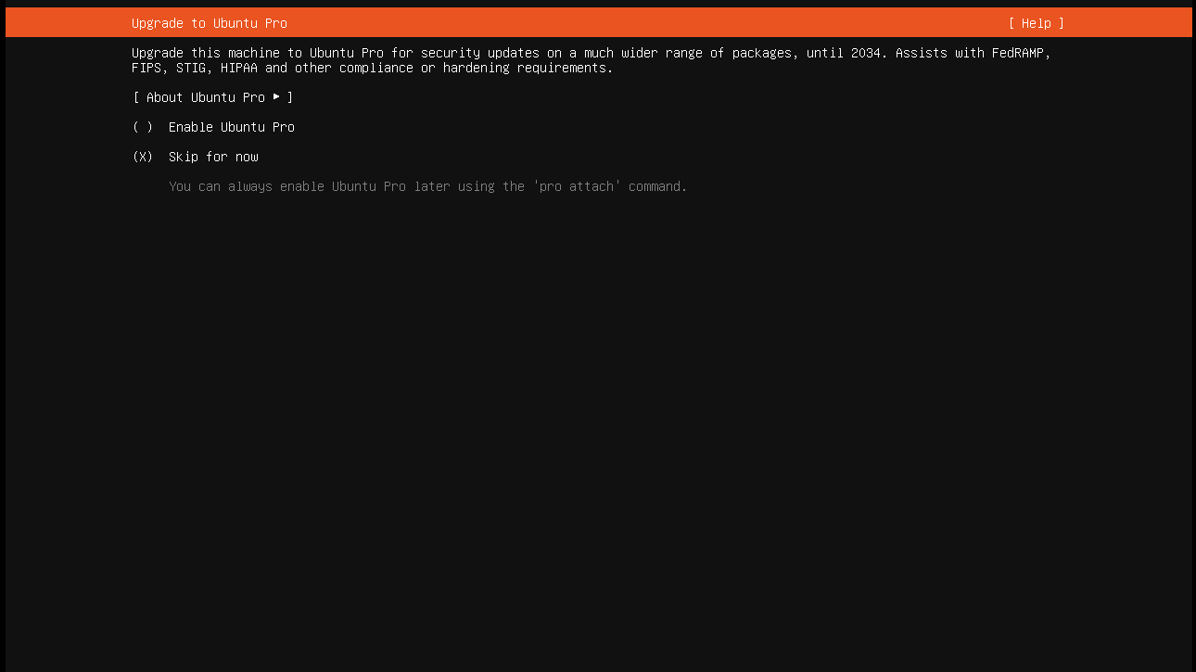

SSH Configuration:

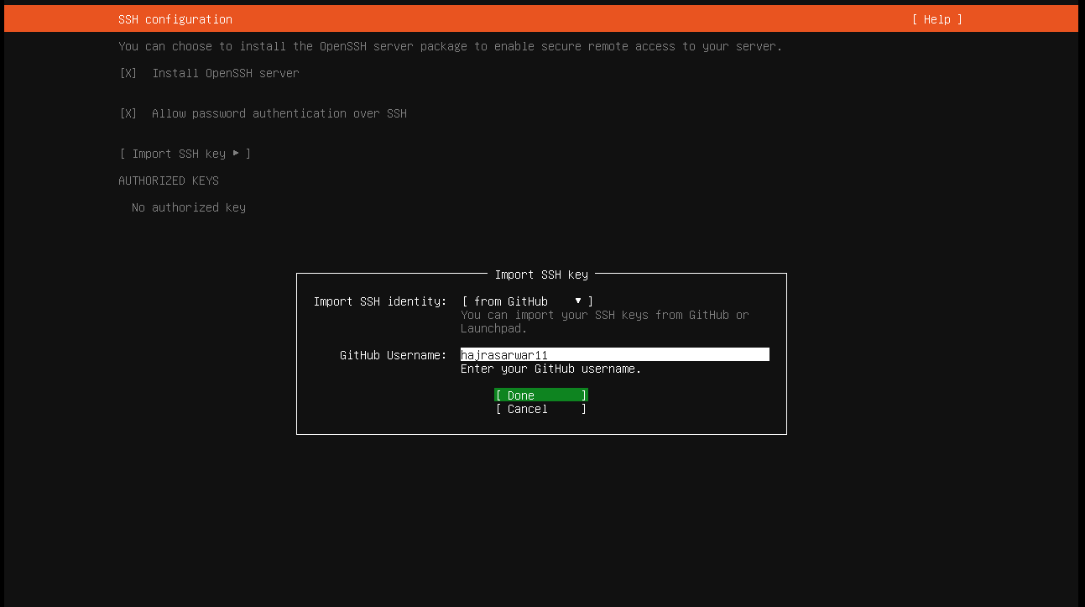

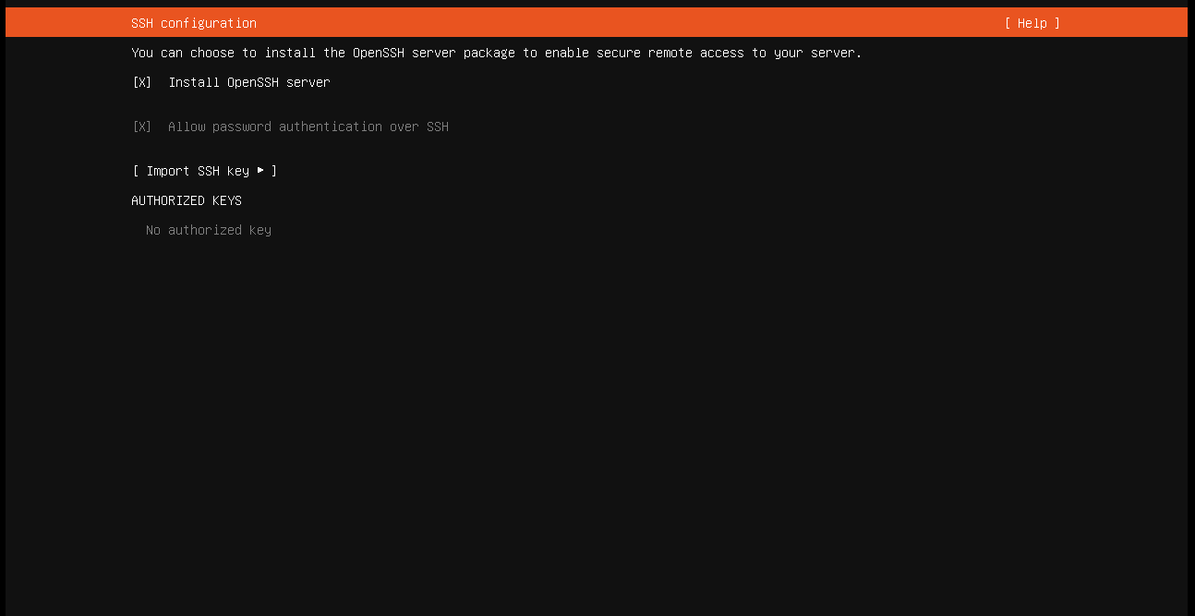

Featured Server snaps:

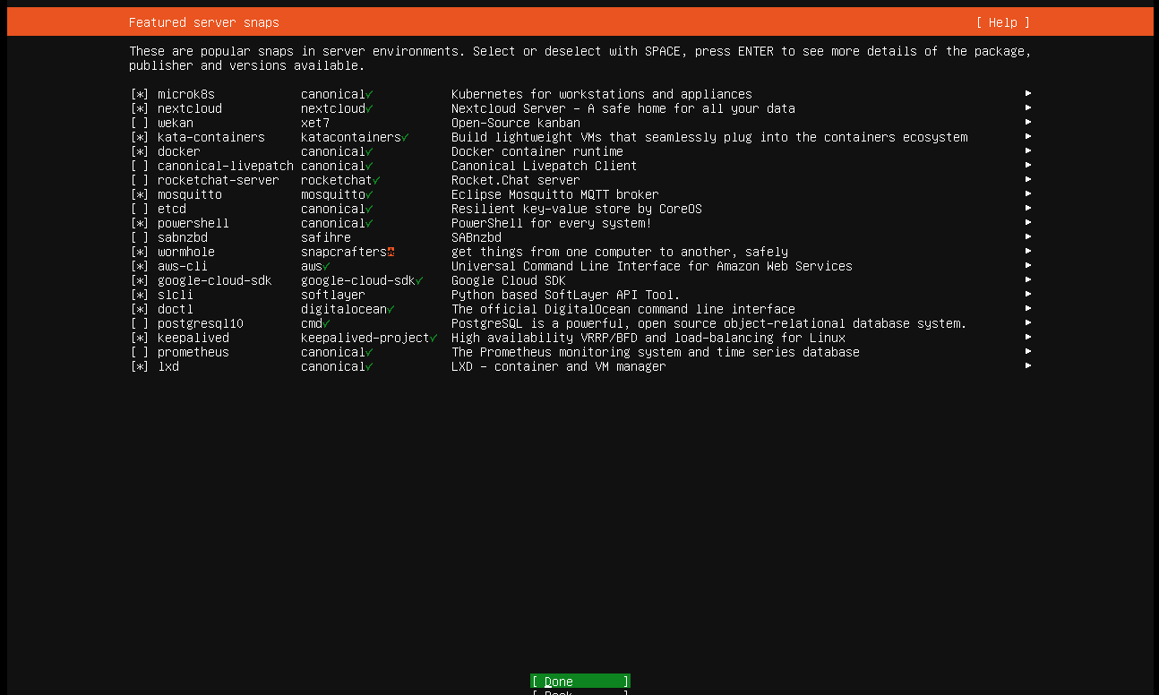

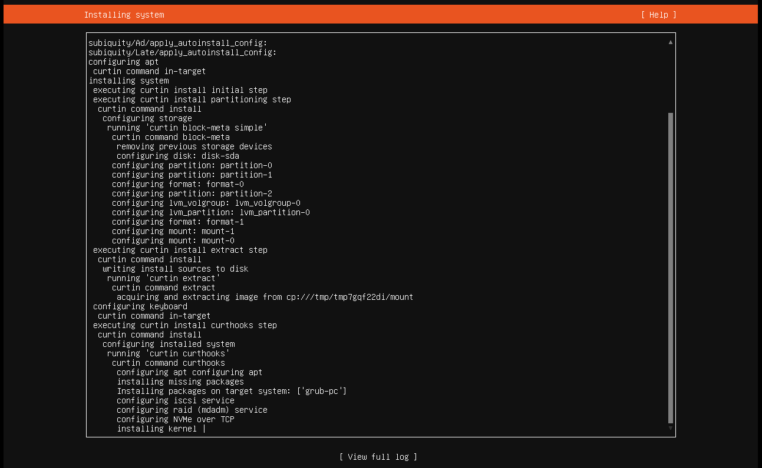 Install Software:

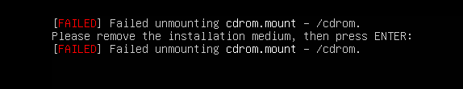 Error:

Go to Virtual Machine setting, click CD/DVD… 🡪 uncheck Connected and connect at power on Boxes 🡪 OK.

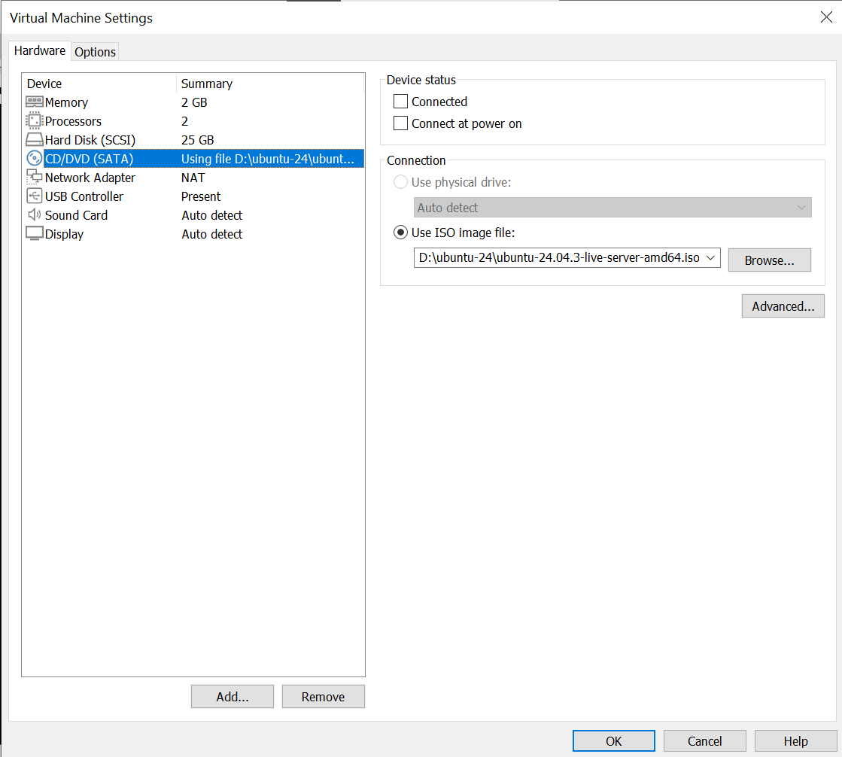

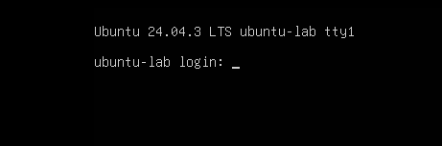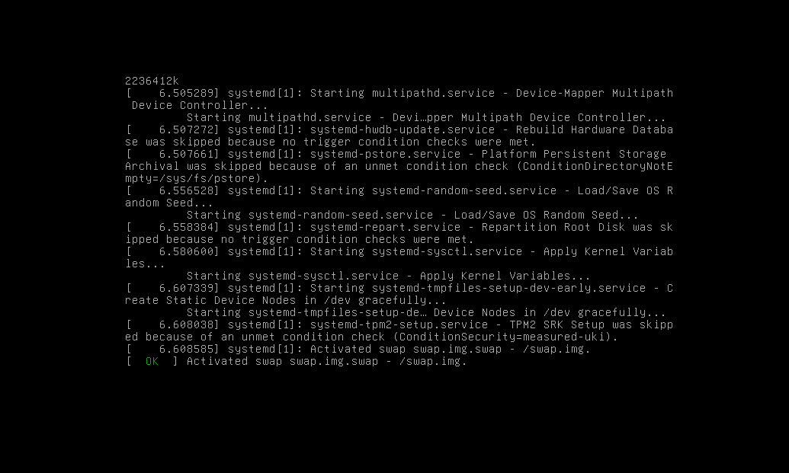

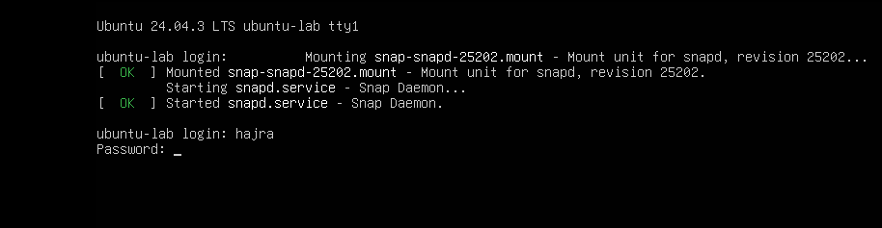

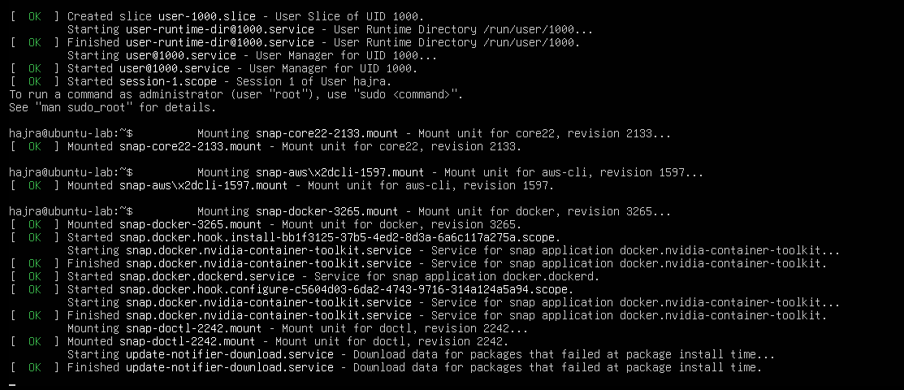

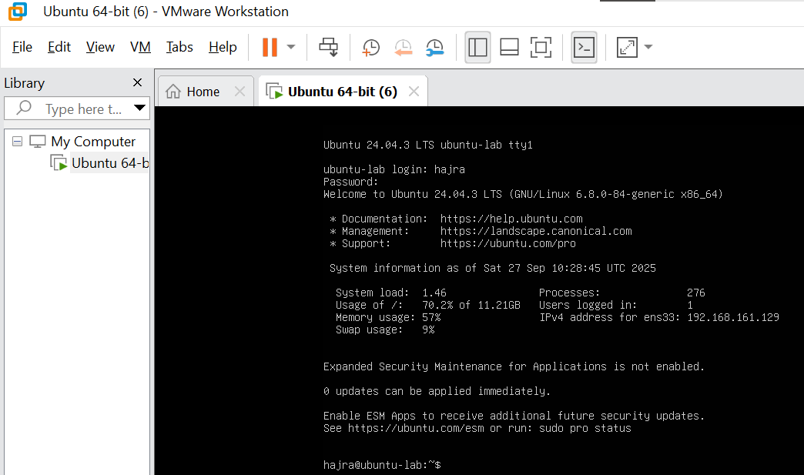

Ubuntu Server Installed Successfully.

1. **Accessing your Ubuntu Server from Windows**
2. 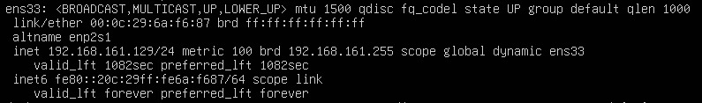Find the IP address of your Ubuntu Server using “ip addr”
3. 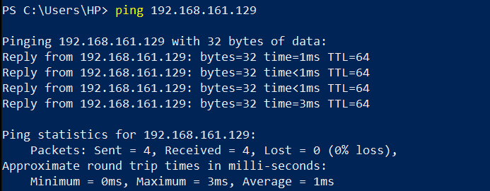Connect via SSH from Windows
4. **Accept the fingerprint** (first time only)  
   Type yes when prompted.

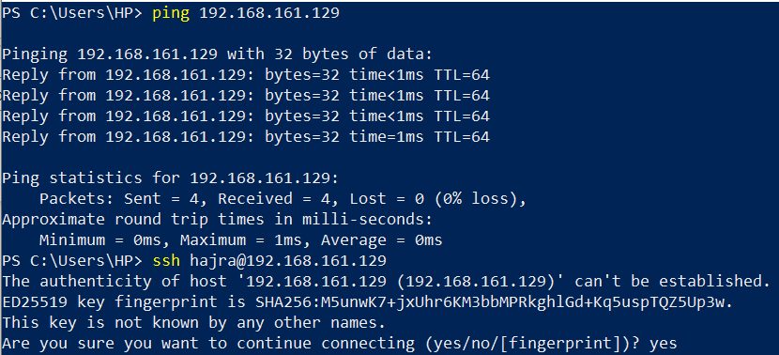

1. 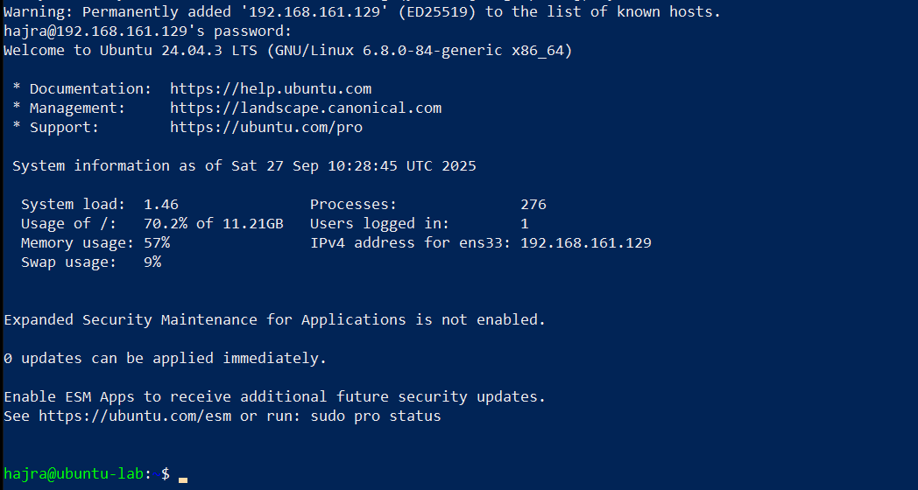**Enter your password**  
   Use the same password you set up during the Ubuntu Server installation.